Lake Shore Central School

Recommended Reading List

K-2

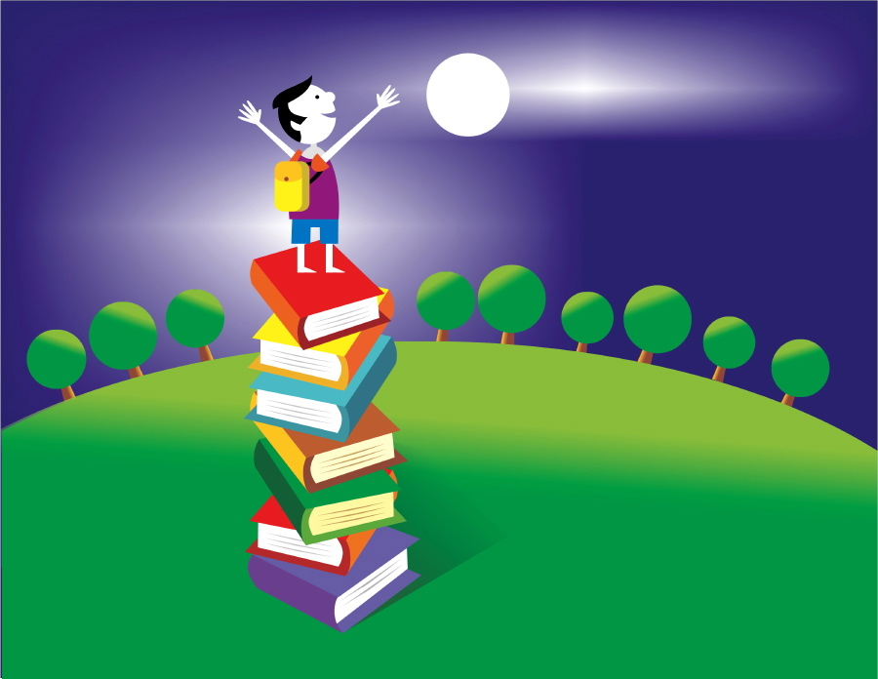

**What is a recommended reading list?**

A recommended reading list is a compilation of titles and authors that are intended to promote good reading habits. There is no greater indicator of a child’s academic success than their reading ability.

This reading list is comprised of book lists from the New York State Common Core materials alongside classical and contemporary works; including a variety of genres both fiction and non-fiction. These lists were created for independent student reading to foster life-long readers.

**You may, of course, read together:**

* By taking turns reading
* By having your child read to you
* By reading to your child

**How does a child choose a book?**

1. Choose a book that you think you will enjoy.
2. Read the second page.
3. Hold up a finger for each word you are not sure of, or do not know.
4. If there are five or more words you did not know, you should choose an easier book.

Remember, you may always ask your child’s teacher or media specialist to recommend more titles for your child to explore.

**Any book that helps a child to form a habit of reading, to make reading one of his deep and continuing needs, is good for him.**

–Maya Angelo

Lake Shore Central Schools

Recommended Reading List

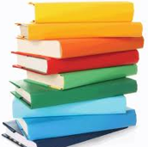

**Kindergarten**

**Author** **Title**

|  |  |
| --- | --- |
| Allard, Harry | **Miss Nelson is Missing** |
| Arnold, Katya | **Elephants Can Paint Too!** |
| Barner, Bob | **Bugs! Bugs! Bugs!** |
| Bridwell, Norman | **Clifford Series** |
| Brown, Marcia | **Cinderella** |
| Burkert, Nancy Ekholm | **Snow White and the Seven Dwarfs** |
| Campbell, Sarah C. | **Wolfsnail: A Backyard Predator** |
| Carle, Eric | **All Books** |
| Cousins, Lucy | **Yummy: Eight Favorite Fairy Tails** |
| Craft, Charlotte & Kinuko | **King Midas and the Golden Touch** |
| Ditchfield, Christin | **Johnny Appleseed** |
| Drummond, Allan | **Casey Jones** |
| Ehlert, Lois | **All Books** |
| Galdone, Paul | **All Books** |
| Keats, Ezra Jack | **All Books** |
| Ketteman, Helen | **Goodnight, Little Monster** |
| Kirk, David | **All Books** |
| Lyon, George Ella | **The Pirate of Kindergarten** |
| Martin, Jr., Bill | **Brown Bear, Brown Bear, What do you See?** |
| Milne, A | **The Complete Tales and Poems of Winnie the Pooh** |
| Numeroff, Laura Joffe | **If You Give a Mouse a Cookie (series)** |
| Seuss, Dr. | **All Books** |
| Shannon, David | **No, David** |
| Wells, Rosemary | **Max and Ruby** |
| Williams, Rozanne Lanczak | **The Counting Book** |
| Yolen, Jane & Andrew Fusek Peters | **Switching on the Moon: A Very First Book of Bedtime Poems** |

Lake Shore Central Schools

Recommended Reading List



**First Grade**

**Authors Titles**

|  |  |
| --- | --- |
| Arnold, Tedd | **Fly Guy Series** |
| Ata, Te | **Baby Rattlesnake** |
| Barrows, Annie | **Ivy and Bean** |
| Berger, Melvin | **Germs Make Me Sick** |
| Bourgeois, Paulette | **Franklin Series** |
| Capucilli, Allyssa | **Biscuit Series** |
| Cole, Joanna | **Your Insides** |
| Frost, Helen | **All Books** |
| Coombs, Kate | **Water Sings the Blue** |
| Cronin, Doreen | **Click Clack Moo: Cows that Type series** |
| Crowley, Joy | **All Books** |
| Davies, Nicola | **Surprising Sharks** |
| DiCamillo, Kate | **Bink and Gollie series** |
| French, Vivian | **Yucky Worms** |
| Frost, Helen | **All nonfiction** |
| Hall, Kirsten | **Ballerina Girl** |
| Henkes, Kevin | **All Books** |
| Hoban, Russell | **Bedtime for Francis** |
| Jenkins, Steve | **All nonfiction** |
| Lin, Grace | **Ling & Ting: Not Exactly the Same!** |
| Lobel, Arnold | **Frog and Toad series** |
| Marshall, James | **All books** |
| Mayer, Mercer | **There’s an Alligator Under My Bed!** |
| McMullan, Kate | **Mouse & Mole: Fine Feathered Friends** |
| Munsch, Robert | **All Books** |
| National Geographic Readers | **Series** |
| O’Connor, Jane | **Fancy Nancy series** |
| Osborne, Mary Pope | **Magic Tree House series** |
| Park, Barbara | **Junie B. Jones series** |
| Rey, H.A. & Margaret | **Curious George** |
| Rylant, Cynthia | **Henry and Mudge** |
| Sayre, April Pulley | **Stars Beneath Your Bed: The Surprising Book of Dust** |
| Sweeny, Joan | **Me and My Amazing Body** |

Lake Shore Central Schools

Recommended Reading List



**Second Grade**

**Authors Titles**

|  |  |
| --- | --- |
| Adler, David | **Young Cam Jansen series** |
| Aliki | **All Titles fiction and non fiction** |
| Antle, Bhagavan | **Suryia and Roscoe: The True Story of an Unlikely Friendship** |
| Barrows, Annie | **Ivy and Bean Series** |
| Blume, Judy | **Freckle Juice** |
| Branley, Franklyn | **Sunshine Makes the Seasons** |
| Brett, Jan | **All Titles** |
| Brown, Marc | **Arthur series** |
| Bunting, Eve | **The Nasty Stinky Sneakers** |
| Cole, Joanna | **Magic School Bus series** |
| Dadey, Debbie | **Bailey School Kids series** |
| Danzinger, Paula | **Amber Brown series** |
| DePaola, Tomie | **All Titles** |
| DiCamillo, Kate | **Mercy Watson series** |
| Dr. Suess | **All Titles** |
| Gibbons, Gail | **All Titles-science nature** |
| Heiligman, Deborah | **From Caterpillar to Butterfly** |
| Henkes, Kevin | **All Titles** |
| Keats, Ezra Jack | **All Titles** |
| Legg, Gerald | **From Seed to Sunflower** |
| Louie, Ai-Ling (retold) | **Yen-Shen: A Cinderella Story from China** |
| Lowry, Lois | **Gooney Bird Greene series** |
| McMilllan, Bruce | **Nights of the Pufflings** |
| Milton, Joyce | **All Titles-biography** |
| Parish, Peggy | **Amelia Bedelia series** |
| Preller, James | **Jigsaw Jones series** |
| Scieszka, Jon & Smith, Lane | **The Math Curse** |
| Silverstein, Shel | **All Titles** |
| Smith, Gail Saunders | **Clouds** |
| Thomson, Sarah | **Amazing series** |
| Viorst, Judith | **Alexander series** |